The natural world is an incredible wonder that inspires us all. It underpins our economy, our society, indeed our very existence. Our forests, rivers, oceans and soils provide us with the food we eat, the air we breathe, the water we irrigate our crops with. We also rely on them for numerous other goods and services we depend on for our health, happiness and prosperity.

These natural assets are often called the world's 'natural capital'. These benefits are also hugely important to the economy – from farming and forestry to leisure and tourism. If you add them all up, the total value of these benefits is phenomenal – **at least US$125 trillion every year**.

Because nature is free, we often take it for granted and overexploit it. We clear forests, overfish oceans, pollute rivers and build over wetlands without taking account of the impact this will have. By not taking into account the benefits we get from nature, we create huge social and economic costs for ourselves.

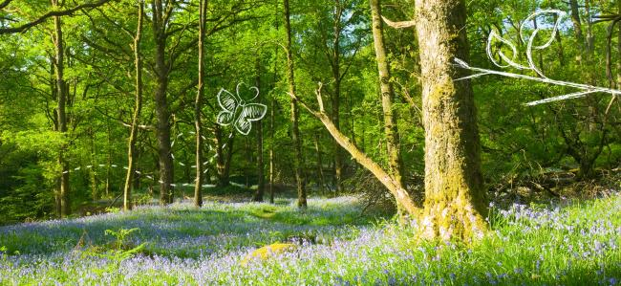

his affinity tends to get knocked out of them as they grow. They come under pressure to put away childish things in favour of passing exams and getting a "proper job".

Along with digital distractions and legitimate fears about playing outdoors, the pressures are removing children from nature before our very eyes. Who can blame them for thinking an apple is a gadget first and a fruit second?

Yet for children and adults alike, daily contact with nature – being in green, open space, near healthy rivers, exploring nature’s colours, sounds, tones and textures — is linked to better health, less stress, better mood, reduced obesity. That’s already an amazing list of features no other product can ever match.

